Exercise 1: Interacting with the User

Ask the user to enter their name and age and then print out the name and age entered. The output of the program should look something like this:

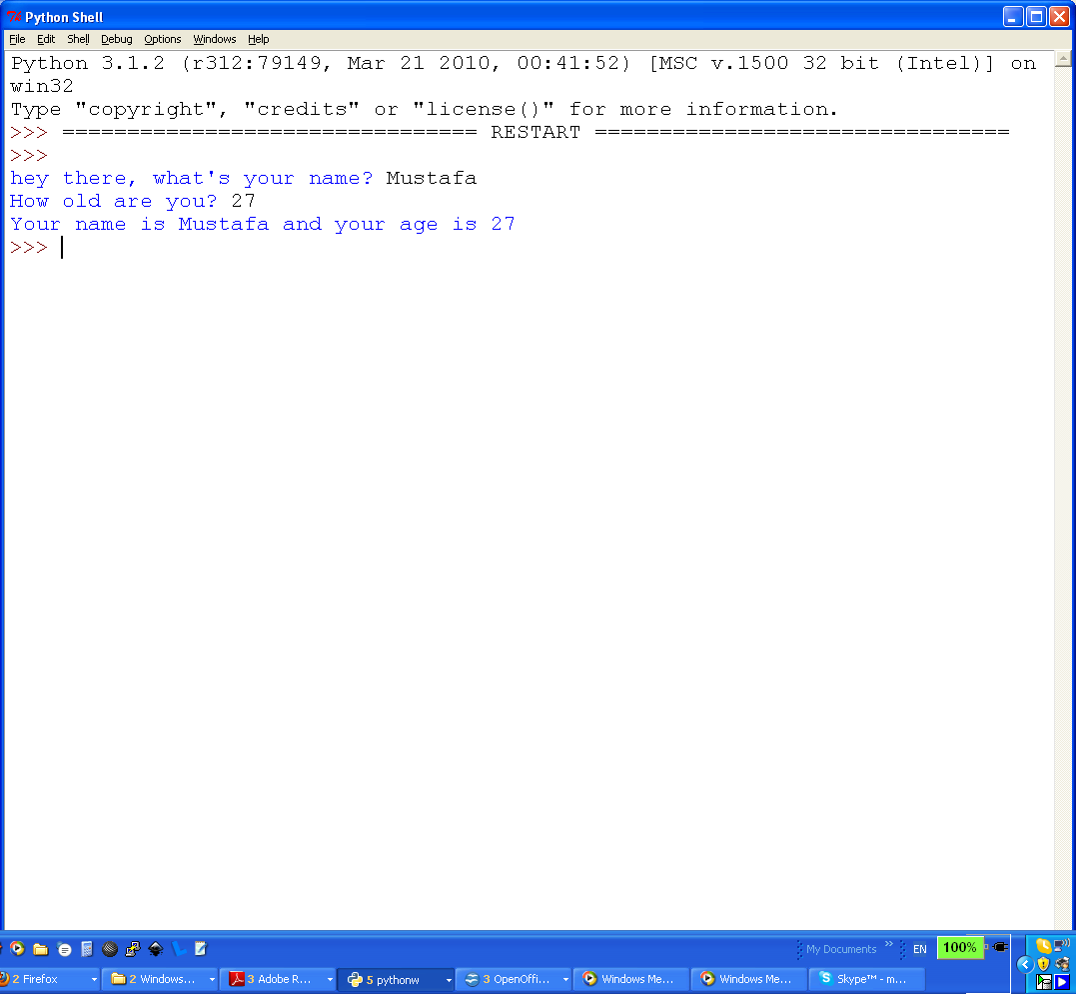

Exercise 2: Grade Program

a) Develop a program that takes asks the user to enter a numerical grade between 0 – 100 and output a letter grade (A,B,C,D,F) based on the value entered. The following table shows the letter grade that should be outputted according to numerical grade:

Letter Grade | Numerical Grade
F | 0 - 49
C | 50 - 69
B | 70 - 84
A | 85 - 100

Sample Output:

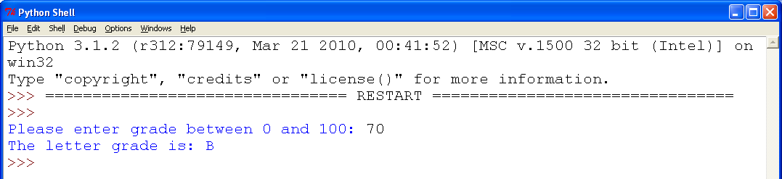

b) Use chained conditional statements to rewrite the program to improve efficiency. Also, add code to handle wrong user input. If the user enters a value outside the range (0 – 100) the program should tell the user that they have entered wrong input and then exit instead of crashing.

Sample output:
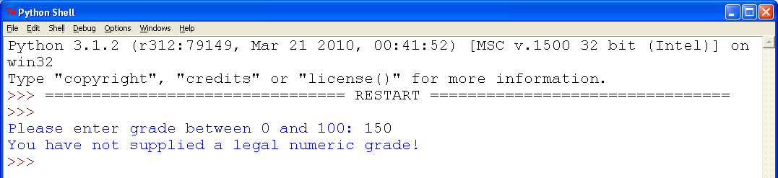

Exercise 3: Sorting Program

Write a program that asks the user to enter three numbers and then outputs the numbers in sorted order.

Sample Output:

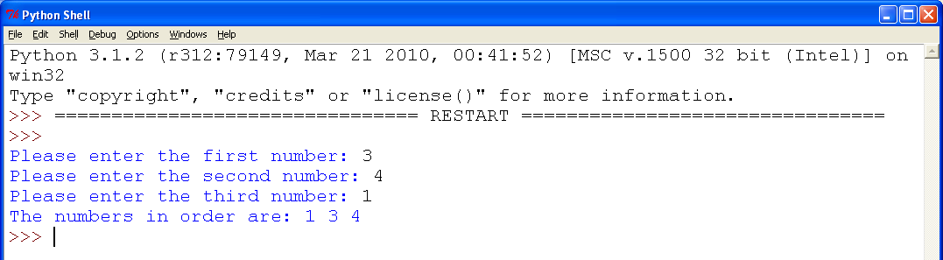

Exercise 4: Factorial Program
Write a program that asks the user for a number and then calculate the factorial of that number. The factorial of a number, n, is denoted as n!.. H

  - n! = (n) x (n-1) x (n-2) x .... x 1
  - For example 5! = 5 x 4 x 3 x 2 x 1

Exercise 5: Average Program
Write a program to ask the user to as many numbers as he wants and then calculate the average of those numbers. If the user does not enter any numbers then tell him that the average can't be calculated because he did not enter any numbers. Your program output should look something like this:

If the user enters some numbers:
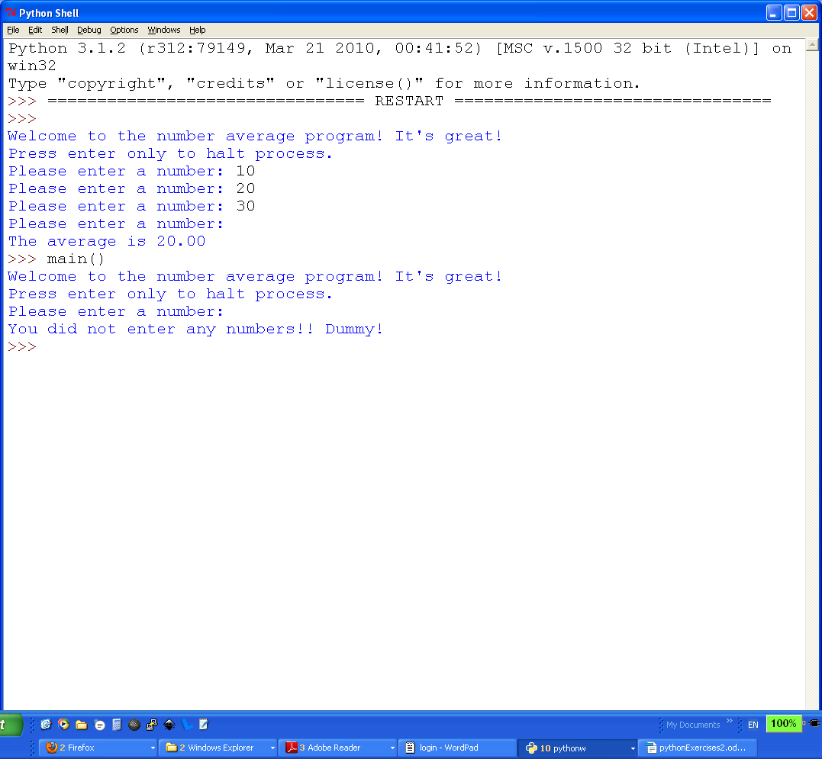

If the user does not enter any numbers by pressing “ENTER” right away:

