Swing Summary Sheet
CISC 323, winter 2006

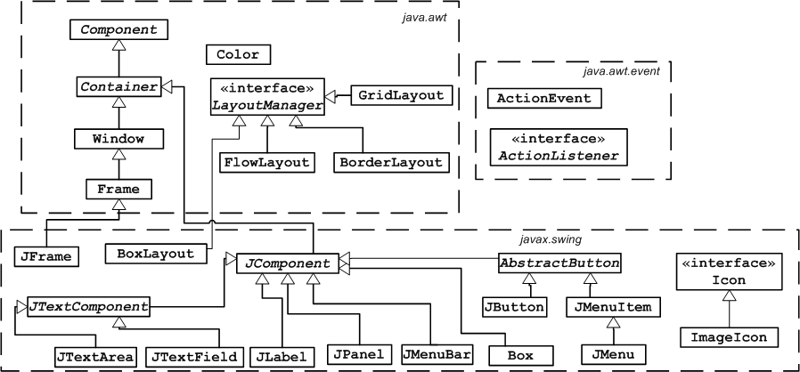

abstract class AbstractButton
void addActionListener(ActionListener l)
String getText()
void setText(String text)

class ActionEvent
Object getSource()
String getActionCommand()

interface ActionListener
void actionPerformed(ActionEvent e)

class BorderLayout
constants: CENTER, EAST, NORTH, SOUTH, WEST
constructors:
BorderLayout()
BorderLayout(int hgap, int vgap)
void setHgap(int hgap)
void setVgap(int vgap)

class Color
constants: black, blue, cyan, darkGray, gray, green, lightGray, magenta, orange, pink, red, white, yellow
constructor:
Color(int red, int green, int blue)

abstract class Component
Color getBackground()
Font getFont() // optional
Color getForeground()
int getHeight()
int getWidth()
void repaint()
void setBackground(Color c)
void setEnabled(boolean b)
void setFont(Font f) // optional
void setForeground(Color c)
void setVisible(boolean b)

abstract class Container
Component add(Component comp) // ignore result
Component add(Component comp, int index)
// second form is for BorderLayout (using
// BorderLayout constants), or adding
// components to a particular position
// in a grid or flow layout
void remove(Component comp)
void remove(int index)
void setLayout(LayoutManager manager)

class FlowLayout
constants: CENTER, LEFT, RIGHT
constructors:
FlowLayout()
FlowLayout(int align)
FlowLayout(int align, int hgap,
int vgap)
void setAlignment(int align)
void setHgap(int hgap)
void setVgap(int vgap)

class Font (optional)
constants: BOLD, ITALIC, PLAIN
constructor:
Font(String name, int style,
int size)
standard font names:
“Serif”, “SansSerif”, “Monospaced”

class Frame
void setTitle(String title)
void setMenuBar(MenuBar mb)

class GridLayout
constructors:
GridLayout(int rows, int cols)
GridLayout(int rows, int cols,
int hgap, int vgap)
void setHgap(int hgap)
void setVgap(int vgap)

class ImageIcon (optional)
constructor:
ImageIcon(String filename)

class JButton
constructors:
JButton()
JButton(String text)
JButton(Icon icon) // optional

abstract class JComponent
void setActionCommand(
String actionCommand)
void setPreferredSize(Dimension preferredSize)
// use new Dimension(width, height)

class JDialog
constructors:
JDialog(JFrame parent, boolean modal)
JDialog(JDialog parent, boolean modal)
contains most methods used with JFrame plus:
void setModal(boolean b)

class JFrame
constructors:
JFrame()
JFrame(String title)
Container getContentPane()
void setContentPane(Container c);
void setDefaultCloseOperation(int operation)
operation = EXIT_ON_CLOSE to exit program
when frame is closed

class JLabel
constants: LEFT, CENTER, RIGHT
constructors:
JLabel()
JLabel(String text)
JLabel(String text,
int horizontalAlignment)
JLabel(Icon image) // optional
String getText()
void setHorizontalAlignment(int alignment)

class JPanel
constructors:
JPanel()
JPanel(LayoutManager layout)

class JOptionPane
static methods:
void showMessageDialog(
Component parent, String message)
String showInputDialog(
Component parent, String message)
int showConfirmDialog(
Component parent, String message)
result of showConfirmDialog is one of:
YES_OPTION
NO_OPTION
CANCEL_OPTION
parent parameter for each above should be
a JFrame or JDialog

abstract class JTextComponent
String getText()
void setEditable(boolean b)
void setText(String t)

class JTextField
constants: LEFT, CENTER, RIGHT
constructors:
JTextField()
JTextField(int columns)
JTextField(String text)
JTextField(String text, int columns)
void setHorizontalAlignment(int alignment)

interface LayoutManager
methods for internal use when implementing
layout managers, not for normal users

class Window
void addWindowListener(WindowListener l)
void pack()

